TECHNICAL PROPOSAL

Design and Development of Web-Based Digital Solution for Municipal Water Supply Service Delivery and Management
Demo Link: https://water-services-portal.onhercules.app/
Email:
Municipal Admin | admin@wsup.demo
Billing Operator | billing@wsup.demo
Service Operator | service@wsup.demo
Executive Viewer | executive@wsup.demo
Password: password123

1. Executive Summary
This proposal presents a practical and cost-conscious approach for designing, developing, deploying, and stabilising a web-based Water Supply Service Delivery and Management System for municipal water utilities. The solution is aligned strictly with the Terms of Reference and is intentionally scoped to cover only the required business functions.
The proposed system will digitise citizen-facing service requests, modernise billing and customer data handling, consolidate external payment information for reconciliation and monitoring, and provide operational as well as executive dashboards for management decision-making.
To keep implementation efficient and maintainable, the system will be built as a common-core web platform with two independent deployment instances. Kalaroa Municipality will be delivered as the base scope, while Cumilla City Corporation will be supported as an optional expansion once the required approval is confirmed. This model allows reuse of the same core product while preserving separate databases, branding, access controls, and operational independence for each utility.
The proposal includes short-cycle development, structured validation workshops, targeted testing, deployment support, one-day user training per municipality, documentation handover, and twelve months of post-deployment technical support for system stabilisation.

2. Understanding of the Requirement
Based on the Terms of Reference, both municipalities currently rely heavily on manual, spreadsheet-based, and semi-digital processes for water service delivery, billing administration, complaint handling, and reporting. The required solution is therefore not a generic website; it is an operational web system that must improve citizen access, support municipal staff workflows, and strengthen management visibility.
The required scope can be grouped into five tightly bounded capability areas:
Required Capability | TOR-Aligned Interpretation
Citizen services | Online submission for new connections, connection modification/reactivation/disconnection, document upload, downloadable copies, and status tracking.
Utility operations | Customer account management, tariff configuration, bill generation and printing, and billing workflow replacement for spreadsheet-based processes.
Payment monitoring | No embedded payment gateway. The platform only captures and consolidates payment data from approved MFS reports and bank records for reconciliation and analysis.
Management visibility | Operational and executive dashboards with KPI monitoring, drill-down visibility, data export, and historical trend analysis.
User support and enablement | Rule-based chatbot, deployment, user training, support, and future readiness for long-term operation and maintenance.

3. Proposed Technical Approach

3.1 Solution Design Approach
The proposed implementation approach is based on developing one shared core application and deploying it as separate municipal instances. This ensures lower development effort than building two different systems, while still meeting the TOR requirement for independent databases, configurations, access controls, and branding.
The solution will be designed around simple, maintainable web modules rather than complex microservice architecture. This is suitable for the scale of the assignment, helps control delivery cost, reduces maintenance overhead, and supports easier handover to municipal users.
The design principle throughout the project will be process modernisation without adding unnecessary technical complexity. In particular, the solution will avoid embedded online payment processing, advanced AI automation, or costly enterprise components that are not required by the Terms of Reference.

3.2 System Architecture
The platform will follow a layered web architecture consisting of a citizen-facing portal, application layer, municipal management layer, database layer, and document storage layer. This structure is sufficient to support citizen applications, complaint handling, billing functions, payment data consolidation, dashboard reporting, and the rule-based chatbot within a single maintainable solution.
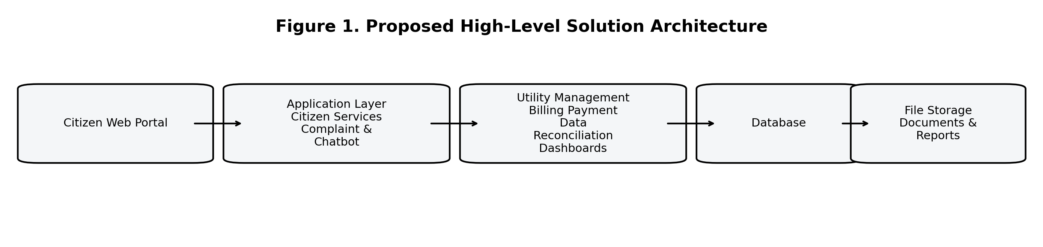
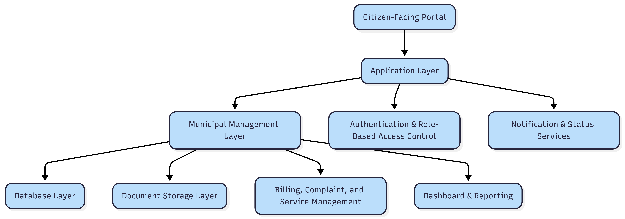

3.3 Data Security and Access Control
Because the system will manage citizen records, supporting documents, billing information, and municipal operational data, the proposed solution will implement role-based access control, authenticated administrative access, encrypted data transmission over HTTPS, password hashing, audit logging for key administrative activities, and strict separation between the two municipal instances.
Uploaded citizen documents will be stored in controlled file storage with access routed through the application layer rather than direct public exposure. Backup routines, environment segregation, and privileged-access limitation will be included as part of deployment and operational configuration.
The security approach will also reflect the TOR assumption that payment execution remains outside the web application. Accordingly, the system will store and analyse payment records for reconciliation and reporting, but it will not process card, wallet, or gateway transactions directly. This reduces both implementation cost and compliance exposure.

3.4 Scalability and Maintainability
The proposed architecture is intentionally lightweight but scalable at the application level. It can support gradual growth in users, records, dashboard data volume, and transaction history by scaling the web server and database resources without redesigning the application.
A modular codebase will allow future enhancements such as additional report types, more workflow rules, or expansion to additional utilities without changing the core product model. At the same time, the shared-core and separate-instance strategy keeps operational independence intact for each municipality.
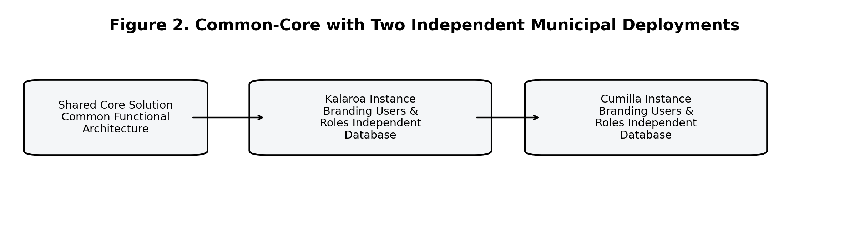

3.5 Operation and Maintenance Mechanism
During the contract period, the consultant will provide hosting or use an existing server if made available, perform initial environment setup, manage deployment, support user acceptance activities, and provide one year of post-deployment support for troubleshooting, bug fixing, and minor configuration adjustments.
For sustainable operation, the system will be delivered with source code handover readiness, technical documentation, user manuals, and administrative guidance. This will support transition to a separate long-term operation and maintenance arrangement if the client elects to proceed after project completion.

4. Proposed Functional Scope
Only the functions explicitly reflected in the Terms of Reference are proposed. The following scope summary is therefore intentionally limited.
Module | Included Scope | Remarks
Citizen Interaction | New connection request, modification/reactivation/disconnection request, document upload, downloadable application copy, status tracking, notifications. | Public-facing web portal
Utility Management | Tariff setup, customer account management, bill generation, bill print support, billing data management. | No extra ERP functions
Payment Data Monitoring | Import or capture of MFS reports and bank payment records for monitoring and reconciliation. | No payment gateway
Operational Dashboard | Billed vs collected, collection efficiency, active connections, applications, complaints, outstanding dues, trends. | KPI-focused
Executive Dashboard | High-level summaries, drill-down records, exportable reports, decision-making visibility. | Authorised roles only
Chatbot Assistant | Rule-based guided support, FAQ guidance, complaint/application redirection, status guidance. | Not AI decision-making
Deployment & Support | Separate instances, training, documentation, hosting/deployment, post-go-live support. | Per TOR

Figure 3: Citizen Service and Billing Information Flow
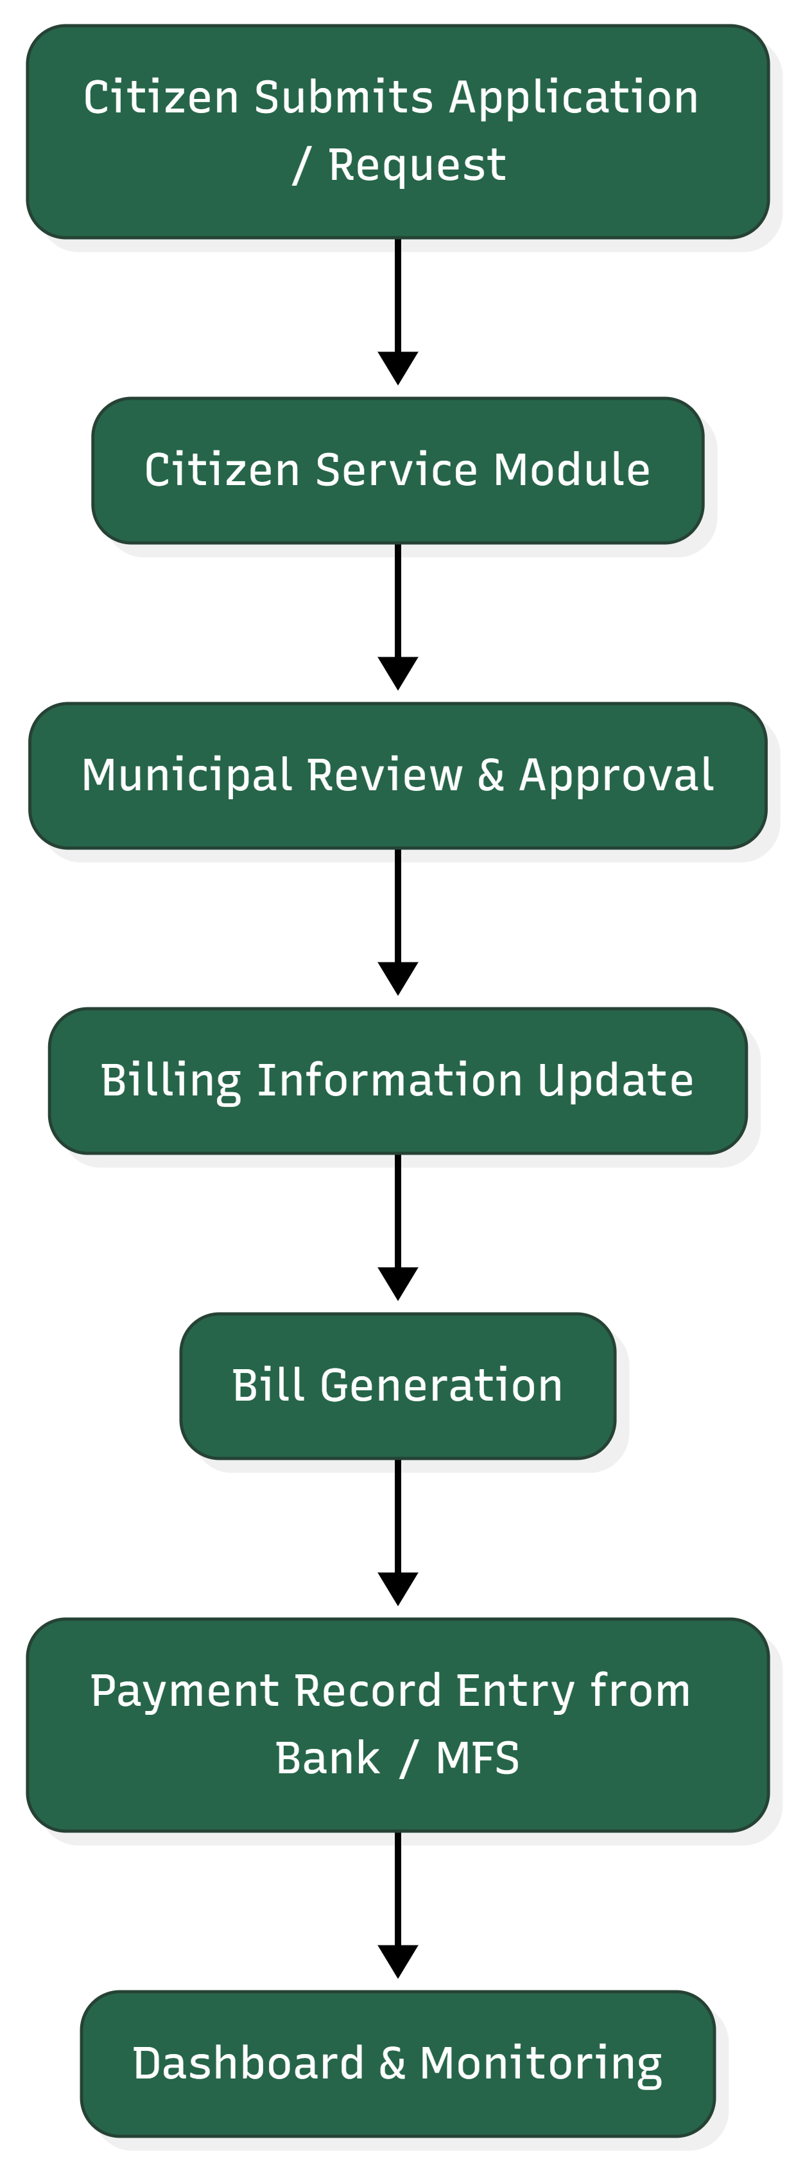

5. Development Methodology
A practical phased delivery methodology is proposed to match the four-month implementation window and the co-creation requirement stated in the TOR.
Phase 1 - Inception and Requirement Validation: Review provided documents, validate workflows, confirm data structures, conduct co-creation sessions, and prepare the detailed workplan and solution blueprint.
Phase 2 - UI/UX and Functional Design: Prepare the approved screen design, information structure, role mapping, and detailed module behaviour with validation from key stakeholders.
Phase 3 - Build and Internal QA: Develop the shared-core application, configure municipal instances, prepare reports and dashboards, complete internal functional, security, and regression testing.
Phase 4 - QA, Deployment, and Handover: Conduct user acceptance testing, implement final corrections, deploy the approved instances, facilitate training, and hand over documentation.
Phase 5 - Stabilization Support: Provide post-deployment technical support for defect fixing, minor adjustments, and controlled operational stabilization.

6. Proposed Technical Stack
The stack below is selected to keep implementation practical, cost-efficient, and maintainable for a municipal web system of this size. It avoids unnecessary licensing costs while supporting secure document handling, role-based administration, dashboards, and reporting.
Layer | Recommended Stack | Reason for Selection
Frontend | Laravel Blade with Bootstrap | Cost-effective web delivery for responsive citizen portal and admin screens without separate frontend framework overhead.
Backend | Laravel (PHP) | Strong fit for rapid CRUD workflows, role-based admin, report generation, document handling, and maintainable web applications.
Database | MySQL | Reliable relational database for customer records, billing data, application tracking, and dashboard aggregation.
File Storage | Server file storage / object storage | Suitable for uploaded documents, generated reports, and controlled file access.
Chatbot | Rule-based guided workflow module | Matches TOR requirement without introducing costly advanced AI complexity.
Hosting | Linux server on cloud VM | Simple hosting model suitable for separate municipal instances and vendor-managed deployment.
Security | HTTPS, RBAC, audit logs, encrypted backups | Baseline security controls required for operational municipal systems.
Reporting | Application-level dashboards and export tools | Supports KPI monitoring, drill-down review, and internal reporting needs.

7. Deliverables
The deliverables below are kept concise but aligned with the TOR expectations.
• Functional web-based application delivered as separate instances for the selected municipalities.
• Citizen service portal covering connection-related applications, document upload, copy download, and status tracking.
• Billing and customer database application with tariff setup, bill generation, printing support, and reporting.
• Payment data capture and monitoring capability for MFS statements and bank payment records.
• Operational dashboard and KPI monitoring views with historical trend support.
• Executive dashboard with high-level summaries, drill-down data visibility, and export support.
• Rule-based web chatbot assistant for citizen guidance and service navigation.
• Hosting, deployment, and initial system configuration.
• User training, manuals, and system handover documentation.
• Twelve months of post-deployment technical support.
• O&M readiness materials for future long-term support arrangement.

8. Testing and Quality Assurance
Testing and quality assurance will be embedded throughout development rather than left only for the end of the project.
QA Area | Planned Activity
Requirement validation | Confirm workflows, roles, forms, dashboards, and data expectations before build starts.
Functional testing | Verify each module includes applications, billing, payment data capture, dashboards, chatbot navigation, and exports.
Data validation | Check field rules, required documents, calculations, and dashboard aggregation logic.
Security testing | Review login controls, role restrictions, audit trail behaviour, and secure file access.
User acceptance testing | Conduct stakeholder validation before production deployment.
Deployment verification | Confirm environment configuration, performance checks, backup readiness, and go-live stability.


9. Implementation Timeline
Total implementation timeline: 3 Months

10. Key Assumptions and Dependencies
The proposal assumes timely availability of baseline records, billing spreadsheets, SOPs, tariff structures, stakeholder participation in workshops and testing, institutional approval before launch, and access to payment statements from approved MFS providers and designated banks. These dependencies are necessary for accurate system configuration and successful deployment.
This proposal intentionally excludes features not required by the TOR, such as embedded payment gateway processing, advanced AI chatbot decision-making, broad ERP coverage, or non-essential third-party enterprise integrations.

11. Conclusion
The proposed solution provides a focused, realistic, and scalable path to digitise municipal water service delivery without overengineering the implementation. It addresses the exact needs stated in the TOR: citizen service access, billing modernisation, payment data monitoring, operational and executive dashboards, rule-based support, and sustainable deployment with training and stabilisation support.
By using a shared-core architecture with independent municipal instances, the implementation remains cost-conscious while preserving data separation, operational control, and future extensibility. This makes the solution suitable for the current assignment and practical for longer-term municipal adoption.

